

A DBMS PROJECT ON “PROTOTYPE OF A BANKING ENTERPRISE”

By: SHIWANI SINGH

Made under the guidance of:

Shruti Patil Ma’am

Department of CSIT

Symbiosis Institute of Technology, Pune

Contents :

No. | Contents | Pg no
1 | ABSTRACT | 2
2 | GENERAL OVERVIEW | 2
3 | AIM | 3
4 | PROPOSED SYSTEM | 4
5 | PROBLEM DESCRIPTION | 4
6 | SOFTWARE PROCESS MODEL | 5
7 | FLOWCHARTS | 6
8 | ENTITIES AND RELATIONS | 8
9 | E R DIAGRAM | 9
10 | ANOMALIES PRESENT | 10
11 | FUNCTIONAL DEPENDENCIES | 11
12 | NORMALISATION | 12
13 | TABLE SCHEMA | 13
14 | SAMPLE QUERIES | 17
15 | CONCURRENCY THROUGH TRANSACTION | 21
16 | PROCEDURES | 22
17 | TRIGGERS | 24
18 | CONCLUSION | 25
19 | BIBLIOGRAPHY | 26

ABSTRACT

The adoption of Electronic Banking by commercial enterprises has been in existence since the mid 90s, much greater in number due to lower operating costs associated with it. Electronic banking has initially been in the form of automatic teller machines and telephone transactions.
More recently, it has been transfer made by the Internet, a new delivery channel for banking services that benefits both customers and banks. Internet banking system services can include: Open an account, Balance enquiry, money deposit. Furthermore, customer’s application for electronic banking facilities is expanding as the cost savings on transactions over the Internet are significant.

GENERAL OVERVIEW :

A Bank is a commercial institution that provides financial services, including issuing money, receiving deposits of money, lending money and processing transactions. A commercial bank accepts deposits from customers and in turn makes loans based on these deposits.
Many banks offer ancillary financial services to make additional profit; for example: selling insurance products. Banking services have expanded to include services directed at individuals and risks in these much smaller transactions are pooled.

In today’s world , the way of functioning and managing the system has been totally changed. There is a sudden and abrupt changes in the structure, maintenance and modification, handling, leveling inside every system. Without managing system through computer applications and programming, the development of infrastructures are unfinished. There are many errors and drawbacks without use of computer programming and applications.
As we know that, ”necessity is the mother of invention”, so in today’s challenging world, every system is developed and launched by the use of computer software and programming.

Aim for this application:

The project that I , have undertaken aims to develop a banking system that is clean, user-friendly and multi-functional. Development of this application includes a number of fields such that user feels comfortable and the system appears as dynamic to him. The project “Banking System” includes the following functionalities:

- Withdrawals can be done efficiently.

- All transactional details and accounts are stored in files on stable storage using DBMS.

- Customers can view their own account details and can use them as necessary using a userID and password.

- Customer can inquire about account, loans, interests, card all online.

- This system possess password-protected administrative access; thus preventing the whole management system from unauthorized access

- To provide flexibility for secure and save deposits and withdrawals.

- For better performance.

- Reducing man power.

- For doing work more accurately.

- Faster performance.

Proposed System And Objectives:

The application will be extremely beneficial for the Customers intending to use and operate their bank account and will get various benefits in the field of management of accounts on a clean and user-friendly platform.
“Bank Account System”, is a simple application, which is especially generated and designed for the bank in order to enter the applicant information about his or her bank . Also the details of all branches and ATMs are stored in the database. It is user name and ID protected as well.

Following are the major objectives behind the new proposed system:

- It creates a user friendly environment, where a normal user can access through all the benefits of the system like loans, interests, cards,transactions.
- It provides security from unauthorized access, only admin or authorized users are access granted to the system.
- It increases efficiency and saves the time.
- Complex Banking operations and Transaction operations are efficiently handled by the application
- It is cost effective
- It has ease of use along with complete reference
- It is highly secured and less time consuming; hence time wastage can be avoided
- Up to date records of the customers are maintained by the authority.

Problem description:
The Bank Management System is an application for maintaining a person’s account in a bank. The system provides the access to the costumer to create an account, deposit/withdraw the cash from his account, take loans, cards,insurances and also to use the ATM. The following documentation provides the specification of the system.
We are mainly concerned with developing a banking system where a Customer can submit his/her deposit amount to bank if he/she has an account or can create a new account in this bank. Customer can also view the status ,use the ATM and can view account balance. One can easily maintain the above things if he/she has an account by login through his unique userID.

SOFTWARE PROCESS MODEL :

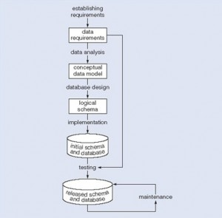

We can use the waterfall cycle as the basis for a model of database development which incorporates three assumptions:
- We can separate the development of a database – that is, specification and creation of a schema to define data in a database – from the user processes that make use of the database.
- We can use the three-schema architecture as a basis for distinguishing the activities associated with a schema.
- We can represent the constraints to enforce the semantics of the data once, within a database, rather than within every user process that uses the data.

Flowchart for deposit and retrieval of money using database:

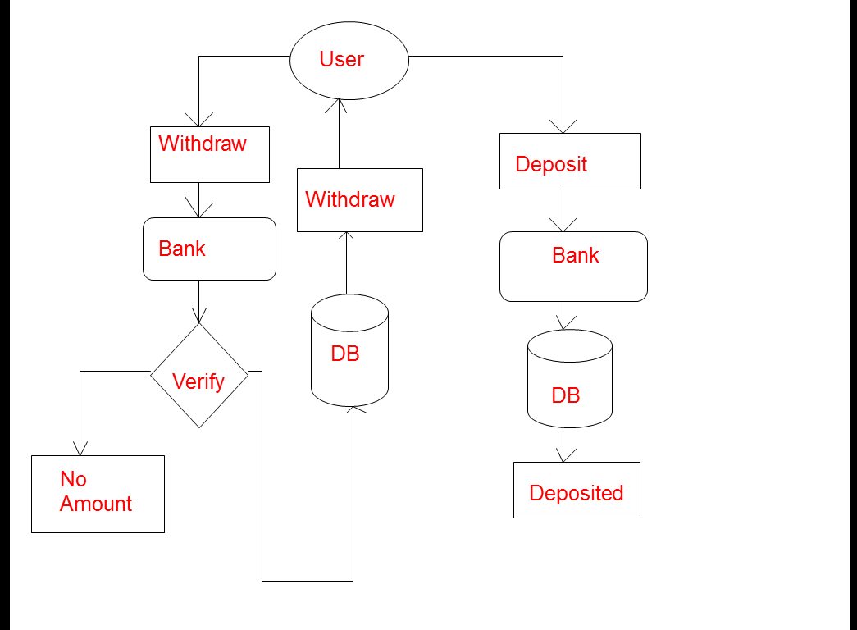

Flowchart for Viewing details using database:

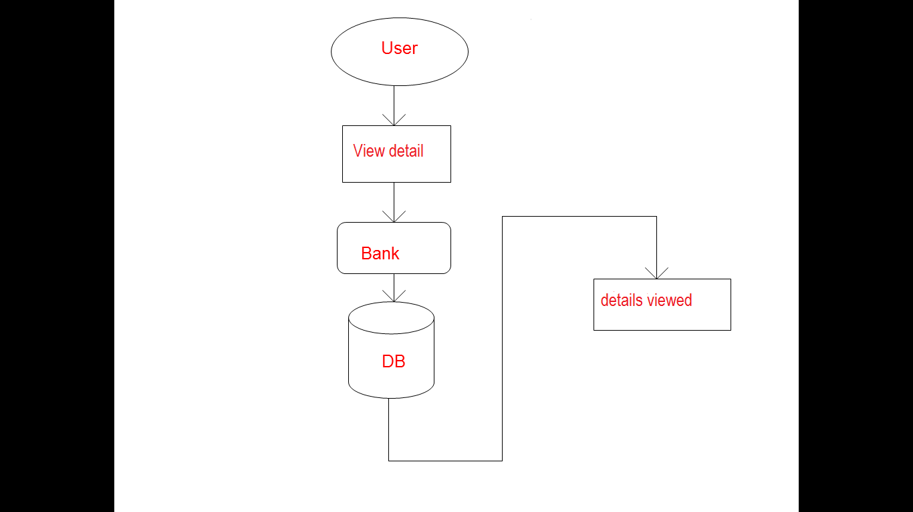

E R diagram :

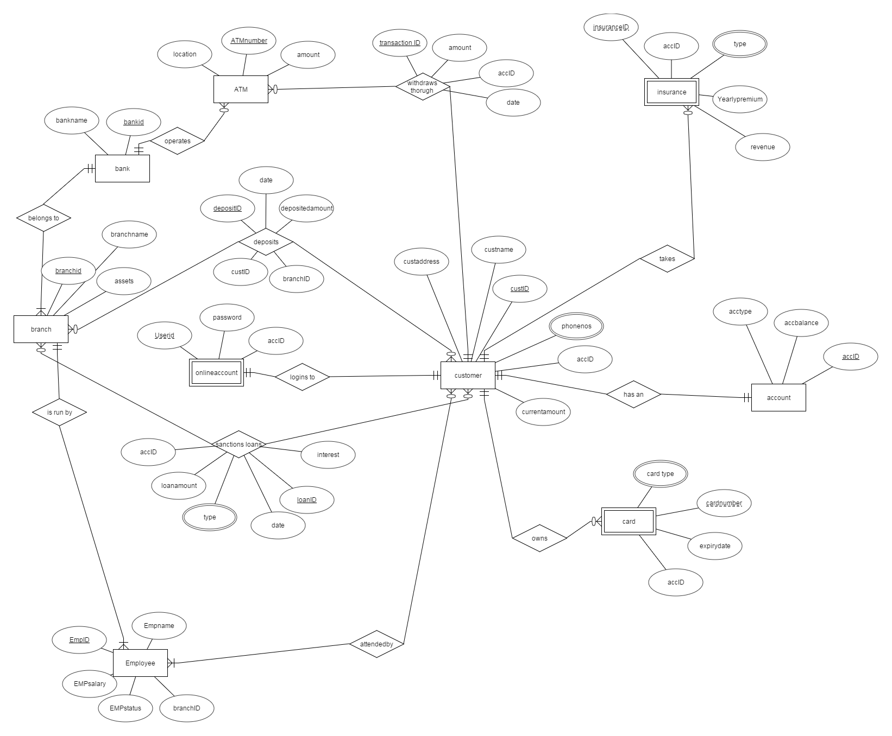
Assumptions:

- Every customer has a minimun deposit 0f Re.1000 in any of the branches.
- Every customer who has an account can avail Card and insurance facility.
- Loans can be taken by any customer.
- Withdrawals are done through the ATM.
Entities and Attributes :

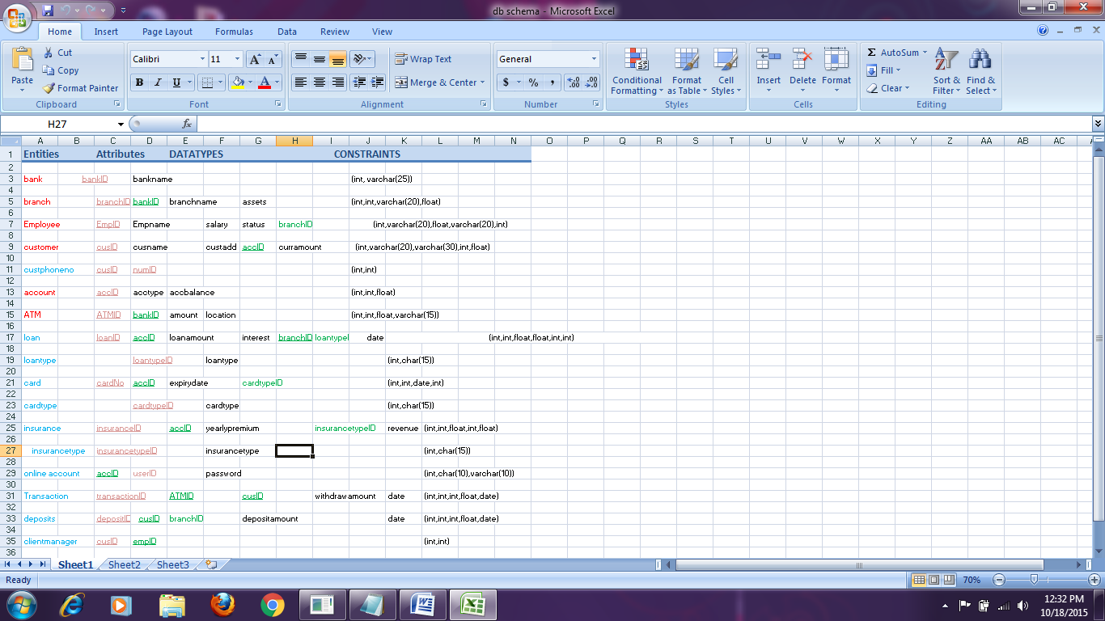

Key:
RED : strong entities
Blue: Weak entities
Pink: primary key
Green : foreign key

ANOMALIES PRESENT :

1 . INSERTION ANOMALIES

As null values are not allowed in a foreign key, the following unwanted insertion anomalies can be seen :

- Employee cant be added without a branch ID.
- Loan cant be added without branchID.
- Transaction cant be processed without ATMID and cusID.
- Deposits cant be processed without cusID and branchID.

2. UPDATION ANOMALIES

If the foreign keys are made without the specification of ON UPDATE ACTION , updation anomalies can arise. However, this project takes care of all such problems by attaching proper actions ( cascade/set null ) to the foreign key constraint.

3. DELETION ANOMALIES

If the foreign keys are made without the specification of ON DELETE ACTION , deletion anomalies can arise. However, this project takes care of all such problems by attaching proper actions ( cascade/set null ) to the foreign key constraint.

ANALYSIS OF FUCNCTIONAL DEPENDENCIES:

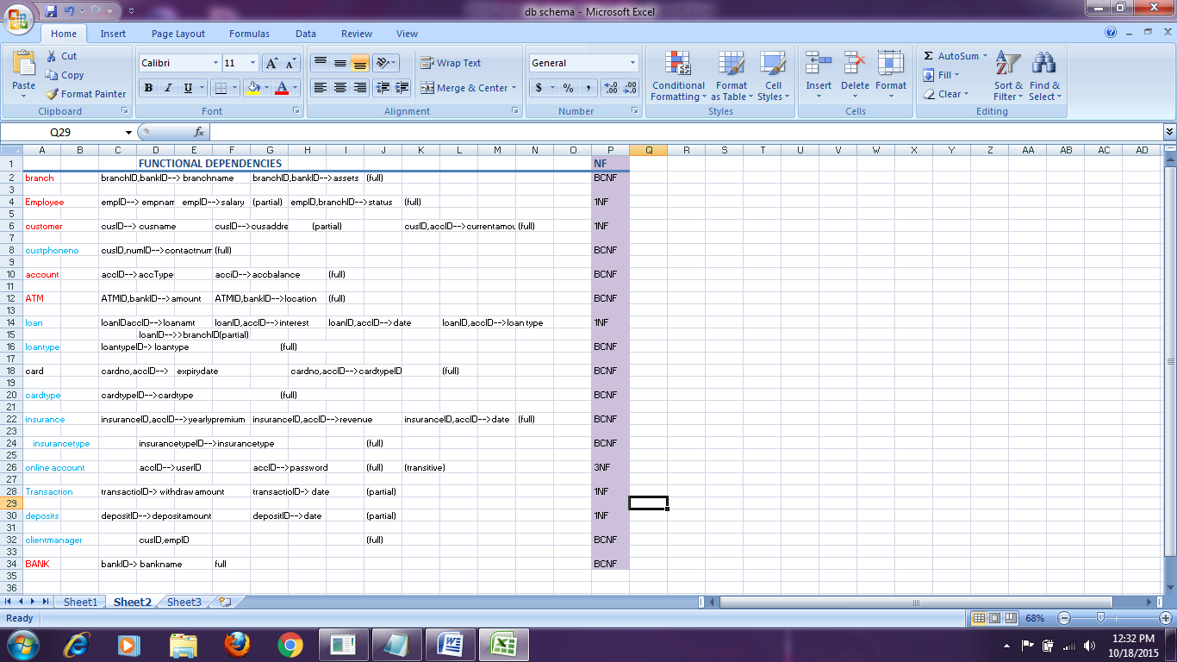

CONVERSION TO NORMALIZED TABLES :

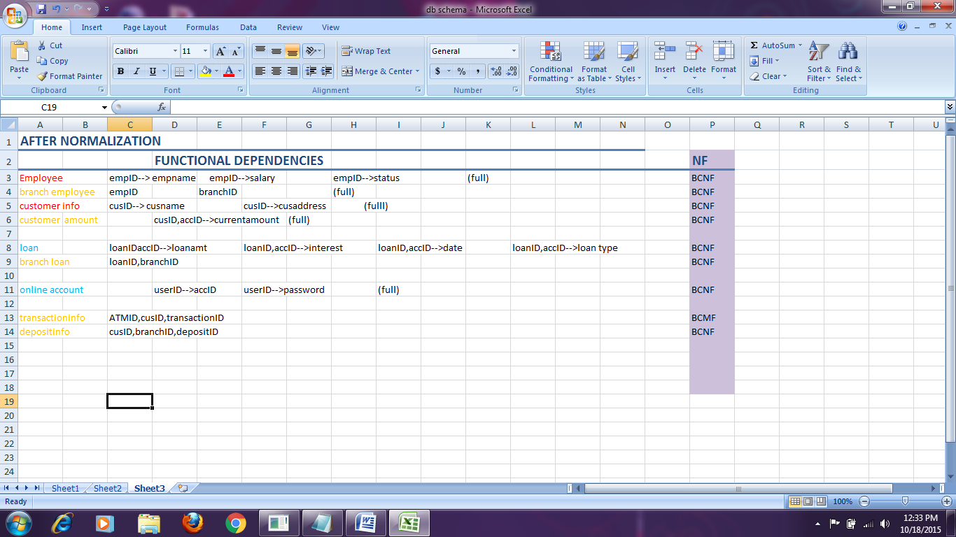

KEY :

RED : existing normalized tables
Orange : new tables added after normalization

TECHNICAL DETAILS :

Table Schemas :

+------------------+
| Tables_in_bankdb |
+------------------+
| account |
| atm |
| bank |
| branch |
| branchemployee |
| branchloan |
| card |
| cardtypes |
| clientmanager |
| cusamount |
| custcontactnum |
| customerinfo |
| deposit |
| depositinfo |
| employee |
| insurance |
| insurancetypes |
| loan |
| loantypes |
| onlineact |
| withdraw |
| withdrawinfo |

1.mysql> desc account;
+---------+-------------+------+-----+---------+-------+
| Field | Type | Null | Key | Default | Extra |
+---------+-------------+------+-----+---------+-------+
| accID | int(11) | NO | PRI | NULL | |
| acctype | varchar(15) | NO | | NULL | |
| accbal | float | NO | | NULL | |
+---------+-------------+------+-----+---------+-------+

2. mysql> desc atm;
+-----------+-------------+------+-----+---------+-------+
| Field | Type | Null | Key | Default | Extra |
+-----------+-------------+------+-----+---------+-------+
| atmID | int(11) | NO | PRI | 0 | |
| bankID | int(11) | NO | PRI | 0 | |
| atmamount | float | YES | | 1000 | |
| location | varchar(10) | NO | | NULL | |
+-----------+-------------+------+-----+---------+-------+

3.mysql> desc bank;
+----------+-------------+------+-----+---------+-------+
| Field | Type | Null | Key | Default | Extra |
+----------+-------------+------+-----+---------+-------+
| bankID | int(11) | NO | PRI | NULL | |
| bankname | varchar(20) | YES | UNI | NULL | |
+----------+-------------+------+-----+---------+-------+

4.mysql> desc branch;
+------------+-------------+------+-----+---------+-------+
| Field | Type | Null | Key | Default | Extra |
+------------+-------------+------+-----+---------+-------+
| branchID | int(11) | NO | PRI | NULL | |
| branchname | varchar(10) | NO | | NULL | |
| assets | float | YES | | 10000 | |
| bankID | int(11) | NO | PRI | 0 | |
+------------+-------------+------+-----+---------+-------+

5.mysql> desc branchemployee;
+----------+-------------+------+-----+---------+-------+
| Field | Type | Null | Key | Default | Extra |
+----------+-------------+------+-----+---------+-------+
| empID | int(11) | NO | PRI | 0 | |
| branchID | int(11) | NO | PRI | 0 | |
| status | varchar(10) | NO | | NULL | |
+----------+-------------+------+-----+---------+-------+

6.mysql> desc branchloan;
+----------+---------+------+-----+---------+-------+
| Field | Type | Null | Key | Default | Extra |
+----------+---------+------+-----+---------+-------+
| loanID | int(11) | NO | PRI | 0 | |
| branchID | int(11) | NO | PRI | 0 | |
+----------+---------+------+-----+---------+-------+

7. mysql> desc card;
+------------+---------+------+-----+---------+-------+
| Field | Type | Null | Key | Default | Extra |
+------------+---------+------+-----+---------+-------+
| cardnum | int(11) | NO | PRI | 0 | |
| accID | int(11) | NO | PRI | 0 | |
| expirydate | date | NO | | NULL | |
| cardtypeID | int(11) | YES | MUL | NULL | |

8. mysql> desc cardtypes;
+------------+-------------+------+-----+---------+-------+
| Field | Type | Null | Key | Default | Extra |
+------------+-------------+------+-----+---------+-------+
| cardtypeID | int(11) | NO | PRI | NULL | |
| cardtype | varchar(10) | NO | | NULL | |
+------------+-------------+------+-----+---------+-------+

9. mysql> desc clientmanager;
+-------+---------+------+-----+---------+-------+
| Field | Type | Null | Key | Default | Extra |
+-------+---------+------+-----+---------+-------+
| cusID | int(11) | NO | PRI | 0 | |
| empID | int(11) | NO | PRI | 0 | |
+-------+---------+------+-----+---------+-------+

10.mysql> mysql> desc cusamount;
+---------------+---------+------+-----+---------+-------+
| Field | Type | Null | Key | Default | Extra |
+---------------+---------+------+-----+---------+-------+
| cusID | int(11) | NO | PRI | 0 | |
| accID | int(11) | NO | PRI | 0 | |
| currentamount | float | YES | | 1000 | |
+---------------+---------+------+-----+---------+-------+

11.mysql> desc custcontactnum;
+------------+---------+------+-----+---------+-------+
| Field | Type | Null | Key | Default | Extra |
+------------+---------+------+-----+---------+-------+
| cusID | int(11) | YES | MUL | NULL | |
| numID | int(11) | NO | PRI | NULL | |
| contactnum | int(11) | NO | | NULL | |
+------------+---------+------+-----+---------+-------+

12. mysql> desc customerinfo;
+------------+-------------+------+-----+---------+-------+
| Field | Type | Null | Key | Default | Extra |
+------------+-------------+------+-----+---------+-------+
| cusID | int(11) | NO | PRI | NULL | |
| cusname | varchar(30) | NO | | NULL | |
| cusaddress | varchar(30) | NO | | NULL | |
+------------+-------------+------+-----+---------+-------+

13. mysql> desc deposit;
+---------------+---------+------+-----+---------+-------+
| Field | Type | Null | Key | Default | Extra |
+---------------+---------+------+-----+---------+-------+
| depositID | int(11) | NO | PRI | NULL | |
| depositamount | float | YES | | 1000 | |
| depositdate | date | YES | | NULL | |
+---------------+---------+------+-----+---------+-------+

14. mysql> desc depositinfo;
+-----------+---------+------+-----+---------+-------+
| Field | Type | Null | Key | Default | Extra |
+-----------+---------+------+-----+---------+-------+
| depositID | int(11) | NO | PRI | 0 | |
| cusID | int(11) | NO | PRI | 0 | |
| branchID | int(11) | NO | PRI | 0 | |
+-----------+---------+------+-----+---------+-------+

15.mysql> desc employee;
+---------+-------------+------+-----+---------+-------+
| Field | Type | Null | Key | Default | Extra |
+---------+-------------+------+-----+---------+-------+
| empID | int(11) | NO | PRI | NULL | |
| empname | varchar(10) | NO | | NULL | |
| salary | float | YES | | NULL | |
+---------+-------------+------+-----+---------+-------+

16. mysql> desc insurance;
+-----------------+---------+------+-----+---------+-------+
| Field | Type | Null | Key | Default | Extra |
+-----------------+---------+------+-----+---------+-------+
| insuranceID | int(11) | NO | PRI | 0 | |
| accID | int(11) | NO | PRI | 0 | |
| yearlypremium | float | NO | | NULL | |
| revenue | float | NO | | NULL | |
| insurancetypeID | int(11) | YES | MUL | NULL | |
+-----------------+---------+------+-----+---------+-------+

17. mysql> desc insurancetypes;
+-----------------+-------------+------+-----+---------+-------+
| Field | Type | Null | Key | Default | Extra |
+-----------------+-------------+------+-----+---------+-------+
| insurancetypeID | int(11) | NO | PRI | NULL | |
| insurancetype | varchar(10) | NO | | NULL | |
+-----------------+-------------+------+-----+---------+-------+

18. mysql> desc loan;
+------------+------------+------+-----+---------+-------+
| Field | Type | Null | Key | Default | Extra |
+------------+------------+------+-----+---------+-------+
| loanID | int(11) | NO | PRI | 0 | |
| accID | int(11) | NO | PRI | 0 | |
| loanamt | float | NO | | NULL | |
| interest | varchar(3) | NO | | NULL | |
| loandate | date | NO | | NULL | |
| loantypeID | int(11) | YES | MUL | NULL | |
+------------+------------+------+-----+---------+-------+

19. mysql> mysql> desc loantypes;
+------------+-------------+------+-----+---------+-------+
| Field | Type | Null | Key | Default | Extra |
+------------+-------------+------+-----+---------+-------+
| loantypeID | int(11) | NO | PRI | NULL | |
| loantype | varchar(10) | NO | | NULL | |
+------------+-------------+------+-----+---------+-------+

20. mysql> desc onlineact;
+----------+-------------+------+-----+---------+-------+
| Field | Type | Null | Key | Default | Extra |
+----------+-------------+------+-----+---------+-------+
| userID | varchar(10) | NO | PRI | NULL | |
| accID | int(11) | YES | MUL | NULL | |
| password | varchar(10) | NO | | NULL | |
+----------+-------------+------+-----+---------+-------+

21.mysql> desc withdraw;
+--------------+---------+------+-----+---------+-------+
| Field | Type | Null | Key | Default | Extra |
+--------------+---------+------+-----+---------+-------+
| withdrawID | int(11) | NO | PRI | NULL | |
| withdrawamt | float | YES | | NULL | |
| withdrawdate | date | YES | | NULL | |
+--------------+---------+------+-----+---------+-------+

22. mysql> desc withdrawinfo;
+------------+---------+------+-----+---------+-------+
| Field | Type | Null | Key | Default | Extra |
+------------+---------+------+-----+---------+-------+
| atmid | int(11) | YES | MUL | NULL | |
| cusID | int(11) | YES | MUL | NULL | |
| withdrawID | int(11) | YES | MUL | NULL | |
+------------+---------+------+-----+---------+-------+

SAMPLE QUERIES :

PROBLEM 1: Ms. Kavya Shrestha wants to open a savings account in BankofIndia with Rs10,000 amount. Assign her account a userid and password to avail the bank facilities. Also, deposit an amount of Rs. 20,000 in her account from Baner Branch of BOI. Display the amount using her userId(ks14).

Solution : mysql> select * from deposit where depositID in(select depositID from depositinfo where cusID in(select cusID from cusamount where accID in(select accID from onlineact where userID='ks14')));

+-----------+---------------+-------------+
| depositID | depositamount | depositdate |
+-----------+---------------+-------------+
| 4315 | 20000 | 2015-08-17 |
+-----------+---------------+-------------+

PROBLEM 2:

Mr. Anirudh wants to issue a credit card(type no- 2). Give him the same. Also display his card details online using his userId 3BN4 alongside his customer details.

mysql> select * from card where accID in(select accID from onlineact where userid='3BN4');
+---------+-------+------------+------------+
| cardnum | accID | expirydate | cardtypeID |
+---------+-------+------------+------------+
| 323 | 4312 | 2023-02-25 | 2 |

mysql> select * from customerinfo where cusID in(select cusID from cusamount where accID in(select accID from onlineact where userid='3BN4'));

+-------+-------------+----------------------+

| cusID | cusname | cusaddress |
+-------+-------------+----------------------+
| 1625 | Mr. Anirudh | #43,Sundar apt, Pune |
+-------+-------------+----------------------+

PROBLEM 3:
Ms. Kavya now wishes to withdraw an amount of Rs 10,000 from Baner ATM. Print the receipt along with the ATM Location usins her customerID-3115.

mysql> select * from withdraw where withdrawID in(select withdrawID from withdrawinfo where cusID=3115);
+------------+-------------+--------------+
| withdrawID | withdrawamt | withdrawdate |
+------------+-------------+--------------+
| 987 | 10000 | 2015-10-18 |
+------------+-------------+--------------+

mysql> select location from ATM where atmID in(select atmID from withdrawinfo where cusID=3115);

+----------+
| location |
+----------+
| SBRoad |
+----------+

PROBLEM 4:
Ms. Kavya had availed the life insurance policy of BOI. She now wants to checks her current status of revenue online using her userID –ks14. Display the same.

mysql> select revenue from insurance where accID in(select accID from onlineact
where userID='ks14');

+---------+
| revenue |
+---------+
| 90,000 |
+---------+

PROBLEM 5:
Mr. Anirudh wants to take a car loan(loan type-3) of 10,00,00.00 from BOI. Print details of his loan amount, date and interest online using his account name.

mysql> select loanamt,interest,loandate from loan where accID in(select accID from cusamount where cusID in(select cusID from customerinfo where cusname='Mr. Anirudh'));

+---------+----------+------------+
| loanamt | interest | loandate |
+---------+----------+------------+
| 10000 | 10% | 2013-09-18 |
+---------+----------+------------+
CONCURRENCY THROUGH TRANSACTION :

Ex. When a bank customer transfers money from a savings account to a checking account, the transaction can consist of three separate operations:
- Decrement the savings account
- Increment the checking account
- Record the transaction in the transaction journal

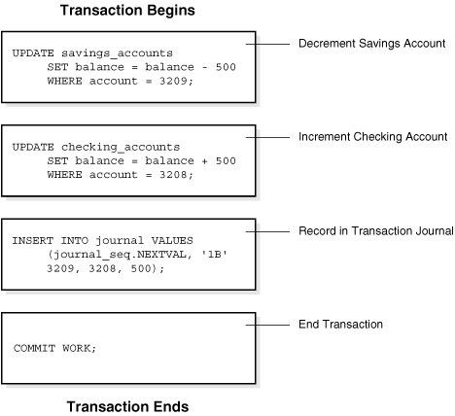

If all three SQL statements can be performed to maintain the accounts in proper balance, the effects of the transaction can be applied to the database. However, if a problem such as insufficient funds, invalid account number, or a hardware failure prevents one or two of the statements in the transaction from completing, the entire transaction must be rolled back so that the balance of all accounts is correct.

PROCEDURES :

Ex 1: To create a procedure to display the amount using the userID online.

delimiter **
create procedure p1 (IN usID text, OUT amt float)
begin
select sum(accbal) into amt from account where accID in(select accID from onlineact where userID=usID);
end **

mysql> call p1('3BN4',@amt)\g
mysql> select @amt \g
+------+
| @amt |
+------+
| 1500 |
+------+

Ex 2: To create a procedure to the type of card being used , using userID.

delimiter **
create procedure pr2(IN usID text, OUT cardtype text)
begin
select cardtype into cardtype from cardtypes where cardtypeid in(select cardtypeID from card where accID in(select accID from onlineact where userid=usID));
end **

mysql> call pr2('3BN4',@cardtype)\g
+----------+
| cardtype |
+----------+
| credit |

Ex 3: To print minimum loan taken from a branch.

delimiter **
create procedure p3(IN bname text, OUT loamt float)
begin
select min(loanamt) into loamt from loan where loanID in(select loanID from branchloan where branchID in(select branchid from branch where branchname=bname));
end **
mysql> call p3('baner',@loanamt)\g

+--------------+
| min(loanamt) |
+--------------+
| 10000 |
+--------------+

TRIGGERS:

Problem: Create a trigger for any update on the card issued by a person

CREATE TABLE card_audit (
cardnum int(11) NOT NULL AUTO_INCREMENT,
accID int(11) NOT NULL,
cardtypeID int(11) NOT NULL,
changedon datetime DEFAULT NULL,
action varchar(50) DEFAULT NULL,
PRIMARY KEY (cardnum)
)

DELIMITER $$
CREATE TRIGGER before_card_update
BEFORE UPDATE ON card
FOR EACH ROW BEGIN

INSERT INTO card_audit
SET action = 'update',
cardnum = OLD.cardnum,
accID = OLD.accID,
cardtypeID=OLD.cardtypeID,
changedon = NOW();
END$$
DELIMITER ;

mysql> select * from card_Audit;
+---------+-------+------------+---------------------+--------+
| cardnum | accID | cardtypeID | changedon | action |
+---------+-------+------------+---------------------+--------+
| 9080 | 4312 | 2 | 2015-10-28 11:40:01 | update |

CONCLUSION :

I started this project with the concept if implementing a real life problem in a Database . In the process, I learnt that we have been using Database Management Systems so unknowingly in our day to day lives, that we often forget their virtues. A decade ago, when every proceeding was done manually we would have never imagined such a software. And hence, we often appreciate the GUI and front end systems and ignore the back end. However, Compared to a manual database, a computerized database is more flexible, compact, and faster. It reduces the probability of inconsistent data. When a database is teamed with a computer, many of the problems with a manual database are eliminated.
A computerized database Provides:
Speed
It can find a specific record or information from among thousands or even a million entries within a second.
Compactness
Since the database records stored in filing cabinets can be stored in a single floppy disk
Flexible
It has the ability to examine information from a number of ways, so you could search for people living in the same city or with persons with the same last names.

I really wish to thank, Shruti Ma’am for giving us an opportunity to appreciate the beauty of databases.

BIBLIOGRAPHY :

- www.erdplus.com/E-Rdiagrams

- https:// en.wikipedia.org/ Database-normalization

- www.bankofindia.com

- www.slideshare.com

--- Thank you,
Shiwani Singh
Prn- 13070121148
TYCS

